The below is from Pub 4012-page K-24
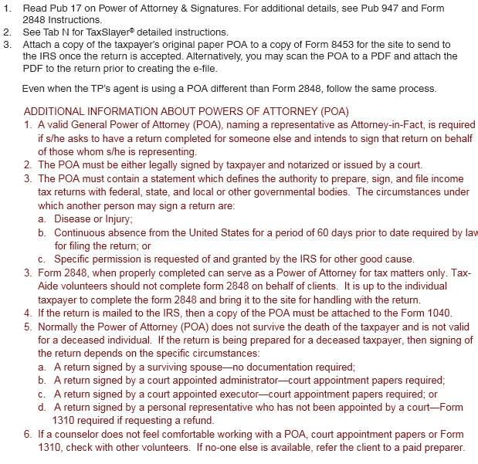
Revised Tax-Aide policy on mailing Form 8453
- Tax-Aide volunteers may elect to NOT send Form 8453 to Austin. Instead, preparers must tell taxpayer to retain the records and advise them which pages to submit if the IRS has questions.
- Sites with scanning capability should continue to attach pdfs of the required pages to the return before e-filing.
- Paper returns should have all documents included.
- Do not send any documents to the local SPEC Relationship Manager

